At the beginning of May 2015, the National Institute for Challenging Homophobia Education (NICHE) partnered with Relationships Australia Tasmania (RA Tas) to provide a week of opportunities for educators, health professionals and homophobia-curious others in the state’s north. This followed NICHE’s week-long visit, last year, to Hobart, Launceston, Devonport, Burnie, Roseberry and Zeehan.

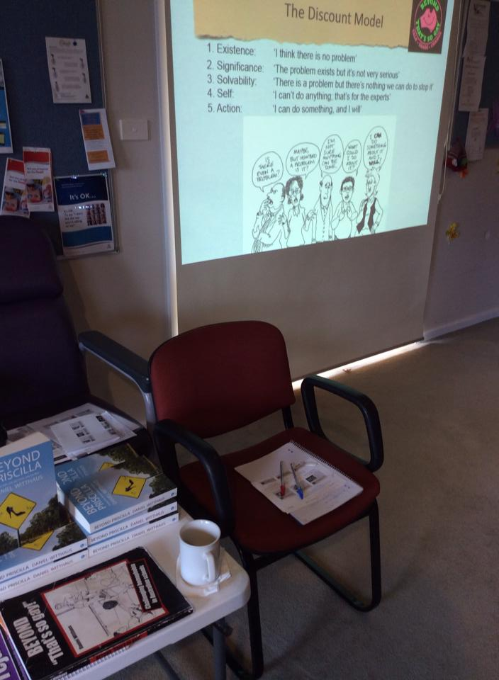
The highlights of this NICHE visit to Tasmania included (attendees in parentheses):
- Professional development on LGBTI support and challenging homophobia for educators and health professionals in Deloraine (12), Smithton (7) and Sheffield (12);
- A workshop focusing on lesbian, gay, bisexual, transgender and intersex (LGBTI) support and leadership for students at Don College (120) from six feeder schools;
- A forum for educators, health professionals and LGBTI community members in Burnie (30) that included the Anti-Discrimination Commission, RA Tas and the Safe Schools Coalition;
- Secondary consultation on LGBTI clients: various.

The NICHE visit to Tasmania saw direct contact with 181 people. This follows the 395 direct contacts NICHE made in August 2014.

Whilst NICHE’s visit in August 2014 drew positive media coverage before, during and after the tour, this visit did not attract any media attention. This demonstrates the value in having the media liaison experience of the Tasmanian Gay and Lesbian Rights Group (TGLRG) and Australian Marriage Equality (AME) last year, that worked with NICHE to promote its visit in the media and create meetings.

Again, those that came into contact with NICHE over this week were not dissimilar to those around the country in regional, rural and remote Australia: they invariably said it was “about bloody time” that LGBTI issues were addressed in their part of Tasmania. More often than not, participants did not need much convincing that there was an opportunity to better support LGBTI people as part of their role, and there was an eagerness to find out what practical tools and strategies worked best.

Of particular note on this NICHE visit, a common response was of surprise and concern that locations like Smithton, Deloraine and Sheffield would be included for workshops and presentations. This demonstrates the ongoing need to explode people’s myths about what LGBTI support work can be undertaken and where. Although smaller in number than places like Hobart, Launceston and Burnie, attendees of professional development were no different in their capacity, motivation and potential to do great LGBTI work.

Key moments
- Health Professional, Deloraine
“I’ve worked with young people for 25 years – with two mainstream organisations – and what struck me today is that at neither of those has there ever been any talk about this issue. I had to come along today as an individual…And if I was to raise this with my organisation tomorrow, they'll say, ‘Yeah, but it’s not an issue for us’…”

- Rural-Based Student, Don College, Devonport
An open invitation to attend a student workshop was offered to Don College’s feeder schools. Projected attendance was 60, yet 120 students and supporting teachers filled the school library.

Following the workshop a young trans person approached, sharing how much they appreciated the workshop’s message of the importance of supportive people: “I’d be dead basically if it wasn’t for [my friends]…”
When asked about what additional supports they had in their small northern rural town, they bluntly shared: “If I came out as trans to my doctor I’m sure he’d probably punch me in the head…Anyway, I came up basically to say thanks for coming down here; for coming to Tasmania; it means a lot to people like me, to people like us. You gave us this opportunity; you have no idea…”

- Suicide Prevention Worker, Sheffield
Post-workshop: “I’m 70 and I was intending to retire from my [suicide prevention in rural Tasmania] position in June, but have reconsidered as a result of this workshop. I found it useful and inspirational…”

- Safe Schools Coalition Project Officers, Burnie
Following a forum in Burnie, both project officers with Safe Schools Coalition were eager to explore how NICHE and RA Tas’ partnership could complement what they are planning to do in the state’s north:
“Can we keep chatting and working together?”

- Landscape, Mole Creek
Perhaps a prophetic start to NICHE’s week in northern Tasmania.
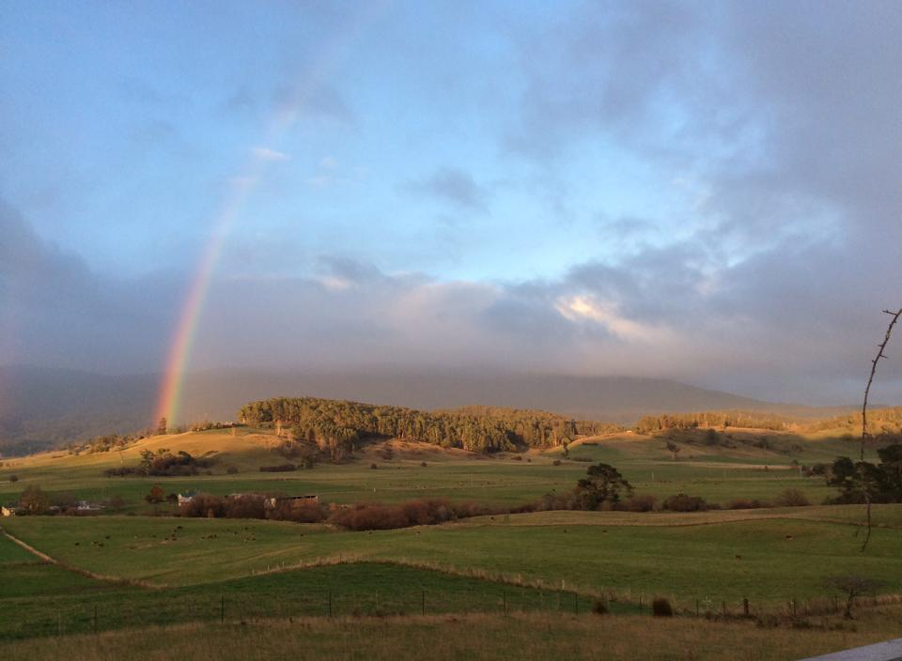

Note: a comprehensive document outlining feedback from various participants has been collated by Sharon Jones, LGBTI Suicide Prevention Project Officer for Northern Tasmania, RA Tas.

Recommendations

After discussions during and after NICHE’s Tasmanian visit with RA Tas’s LGBTI Suicide Prevention Project Officer North, Sharon Jones, there appears to build on and extend the partnership with RA Tas, in order to work on both the West and East Coasts.

NICHE’s previous report on the August 2014 visit outlines a three-stage project that would involve minimal investment to achieve a significant, evaluated project over 18 months.

In addition to this recommendation, there is an opportunity to do substantial work within schools in Tasmania’s north. This could complement the recommendations made by the LGBTI Suicide Prevention Community Action Plan (2013) developed by RA Tas.

Both Daniel Witthaus and Rodney Croome have had very positive preliminary discussions with the Department of Education’s Professional Learning Institute (PLI). Head of the PLI, Shane Frost, has discussed the possibility of the PLI to engage NICHE’s Daniel Witthaus to develop an LGBTI Roadmap for Tasmania’s schools involving consultation, development and piloting. Doing such work in the north of Tasmania could only strengthen any project findings.

The potential for a partnership involving RA Tas would only be a strength for any project proposal going forward.

Finally, the two NICHE rural visits – in August 2014 and the present visit – have created an interest and opportunity for NICHE to again partner RA Tas for a third visit to the state’s north in the next 6-12 months.

SPECIAL THANKS

This visit to Tasmania by the National Institute for Challenging Homophobia Education could not have happened without the generous support and established networks of:
- Relationships Australia Tasmania, especially the expertise, local knowledge and reputation (and company) of Sharon Jones;
- Tasmanian Gay and Lesbian Rights Group/Australian Marriage Equality, especially the expertise, local knowledge and reputation of Rodney Croome.

